Exercise 1 Fish Population model

• Define/articulate the Issue/Problem (focus the effort)

* explicit purpose – The purpose of this model is to examine the ebbs and flows of a fish population. I would like to know what will happen to the fish population under these parameters.
* Reference Behavior Pattern (RBP) – The RBP in this model is that fish are born and die based on population density, and are born based on the number of mature fish divided by the number of mating individuals. We will not examine the ratio of females to males as this is not a controllable variable. We will also not look at cause of death, so the number of fish harvested is not in this model. All piscine deaths will be tallied the same, regardless of eventual tastiness quotient.
* select one or two key measureable aspects of the real world that summarize or encapsulate the behavior of interest
  + I will be collecting historic data regarding population density and Juvenile/Adult quantities.
  + document the values over time for these key aspects
    - Fish Population Density
      * t0 = 0.1
      * t10 🡪 t36 = 0.68
    - Juveniles
      * t0 = 90
      * t10 🡪 t36 = 366

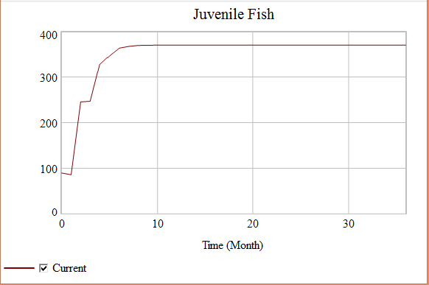

* + - Adults
      * t0 = 10
      * t10 🡪 t36 = 300

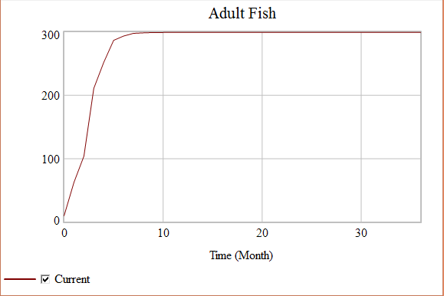

* + should capture the essential qualitative behavior
    - It seems to capture growth followed by stagnation
  + growth, oscillation, growth followed by stagnation, overshoot & collapse, perpetual delays, etc.
    - It seems to capture growth followed by stagnation

• Formulate Model

* Develop & Represent Dynamic Hypothes[es]
  + dynamic organizing principle
    - My theory is that the fish population will see a growth and plateau into an equilibrium.
  + map the hypotheses
    - I expect that the population will grow quickly and stabilize equally quickly.
* Think operationally: make the map simulatable
  + id. storages
    - Juvenile fish
    - Adult Fish
  + characterize flows
    - Max Birthing Rate
    - Min Dying Rate
    - Maturing Rate
  + id. feedback loops
    - Breeding Cycle
      * Adult Fish 🡪 Fish Population Density 🡪 Current Birth Fraction 🡪Birthing 🡪 Juvenile Fish 🡪 Maturing 🡪…
    - Growth Cycle
      * Adult Fish 🡪 Birthing 🡪 Juvenile Fish 🡪 Maturing 🡪…

**Model of a Fish Population**

* + - * 
  + specification and calibration (determine equations & parameters)
    - Initial fish population, N(t=0) = 100
    - Initial Juveniles = 90
    - Initial Adults = 10
    - Carrying Capacity, K=1000
    - Total Simulation Time = 36 months
    - Maximum Birth Rate = 0.5 (in other words, no more than 50% of the population reproduces in any time period)
    - Minimum Death Rate = 0.1 (at least 10% of the fish population dies in any time period)
    - Fish Population Density: (Adult Fish+Juvenile Fish)/"Carrying Capacity (K)"
    - Max. Birthing Faction = Fish Population Density*0.5
    - Current Birthing Fraction = Max Birth Fraction/Fish Population Density
    - Birthing = (Adult Fish*Max Birth Fraction)
    - Juvenile Fish = Birthing-Maturing
    - Maturing = Juvenile Fish*0.6
    - Adult Fish = Maturing-Dying
    - Dying = Adult Fish*Current Death Fraction
    - Min Death Fraction = 0.9
    - Current Death Fraction = Fish Population Density/Min Death Fraction

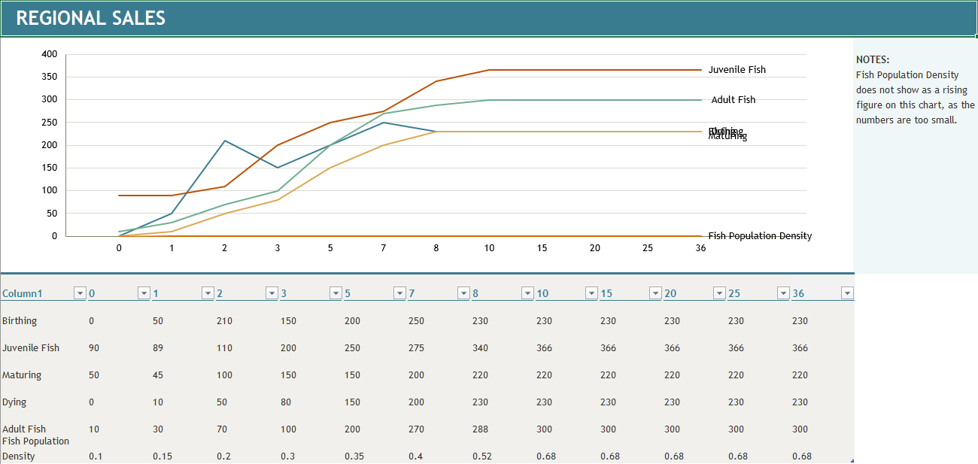

• Test Model

* + mechanical mistake tests
    - It appears to be functional.
  + robustness tests
    - I have increased the initial fish population to equal 900, and the same behavior was observed
    - I have decreased the initial fish population to equal 10, and the same behavior was observed
  + diagnosing surprise behavior
    - I am not seeing any behavior which I find surprising.
* Verification
  + understanding model behavior/dynamics
    - We are seeing a classic rapid population growth to fill an available habitat and an equilibrium.
  + hypothesis tests
    - I have run the model and my hypothesis seems to hold true.
  + exploring dynamic behavior
* Validation
  + challenge the boundaries (extensive & intensive)
    - I have changed the initial values of Juveniles and Adults, as well as the Maturation rate.
      * Changing Adults to 50 and Juveniles to 50 gave similar results. The equilibrium point remained the same.
      * Changing Adults to 100 and juveniles to 600 gave similar but larger results, the equilibrium point remained the same.
      * Changing Maturation Rate to 0.3 gave me an equilibrium point that was higher in Juveniles and lower in Adults, but that was expected. Reversing the calculation caused the expected reversal of stock quantities but otherwise similar results.

• Model Application & Transfer

* Design and Evaluate Policies
  + policy/theory
    - The operating policy set is simply that fish are born at a rate commensurate with the population density and the Adult breeding population. The breeding population is no more than 50% of the Adult population, and the Maturation Rate is set to allow for 40% of the Juvenile population to become Adults. The death rate is commensurate with the population density and the Adult population. We are unrealistically assuming that no Juveniles die.
  + Sensitivity
    - The maturation rate seems to be the variable most sensitive to change.
  + scenarios
    - This is a maintained fishery, and thus interventions of added fish are expected at some point. We will introduce a pulse at time 5 adding 100 Adult Fish in a single drop. We will compare stocks of Adult Fish afterward to see if there is a significant difference.
    - It is my expectation that we will see a faster rise and a slight overshoot before rebounding back to the initial equilibrium point.

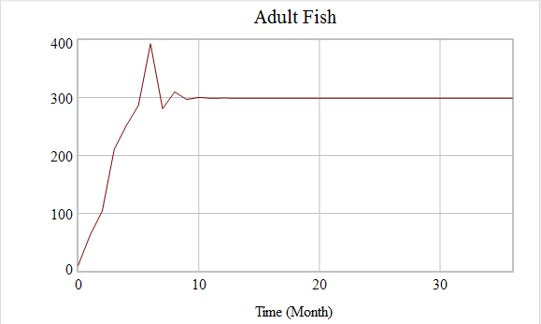

* + - This is indeed what we see in these results, there is a slight overshoot and a return to the same equilibrium point, The reason is that the equilibrium point has more to do with the carrying capacity than anything else.
* Make Learning Available (communicate)
  + develop a drama
    - This model represents the month-by-month growth and population of a stocked and maintained fish hatchery. Using this model, we can experiment with allowing different maturation rates and starting quantities of Adult and Juvenile fish. We can find the most sensitive variables and the optimal initial values for targeting population density / environmental capacity stability.
    - We will experiment with differing ratios of initial Adult / initial Juvenile Fish, as well as changing the initial total population.
    - We will experiment with changing the monthly volume of Juveniles allowed to reach maturity.
  + design a learning progression
    - We will experiment with differing ratios of initial Adult / initial Juvenile Fish, as well as changing the initial total population.
    - We will experiment with changing the monthly volume of Juveniles allowed to reach maturity.
    - Success will be defined by the identification of emergent patterns and properties, and the discovery of individual variable sensitivities and response patterns to variable changes.
  + implement a learning progression
    - To begin, the model will be created and tested.
    - Second, the baseline values will be entered and recorded.
    - The results will now be validated by the challenging of all known and/or expected limitations. In this case; we will expand the time horizon to 100 months, we will stock the fishery to and over carrying capacity, and we will minimize and maximize the maturation rate to find breaking points.
    - Finally, the variables will be methodically altered following tolerances and results recorded to establish patterns and/or properties as well as any emergent patterns/properties.
* Conclusion
  + This model appears to successfully simulate the aging chain of a fish population.
* What I learned
  + I have learned how to create a model in Vensim, and to test the model for correctness, robustness of calculations, and how to locate system sensitivities.
* Potential Improvements
  + This is an over-simplified model of a fish population. There are a great many factors which need to be introduced to closer model reality. This model needs representation of predation and the death of juveniles.